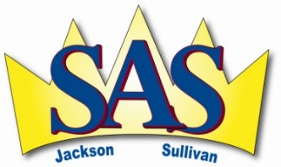
October 3, 2018

Salmon Arm Secondary School
Adaptations Report

Student:
Category: Choose an item. Disability:
The following adaptations are being provided for this student:
Instructional and Assessment Adaptations

☐ CEA support in class
☐ LR block
☐ Organizational support (checklists, agenda etc.)
☐ Notes/ highlighted text provided as necessary
☐ Focus on key concepts from the curriculum
☐ Extra cues/prompts given
☐ Use of graphic organizers
☐ Clarification/repetition of instructions
☐ Use of a calculator

☐ Reteaching of concepts
☐ Audio books provided
☐ Criteria sheet for homework
☐ Simplified or alternate assignments provided
☐ Chunking of assignments
☐ Reduced amount of work
☐ Extra time
☐ Small group instruction
☐ Computer / iPad access
☐ Hands on learning when possible
☐ Alternate forms of assessment
☐ Use of spell check/no penalty

Environmental Adaptations

☐ Alternate work setting/quiet space (counselling or LRC)
☐ Alternate space for testing
☐ Preferential seating
☐ Preferential scheduling
☐ Ongoing LRT and classroom teacher consultation
☐ Ongoing parent contact

Adjudication Information

☐ Scribe provided when necessary
☐ Reader provided when necessary

Case Manager: Psych Ed date:

